Chemistry 141 Name

Dr. Cary Willard

Exam 3 November 15, 2008

|  |  |  |
| --- | --- | --- |
|  | Points Earned | Points Possible |
| Page 3 multiple choice |  | 28 |
| Page 5 |  | 7 |
| Page 6 |  | 21 |
| Page 7 |  | 13 |
| Page 8 |  | 12 |
| Page 9 |  | 6 |
| Page 10 |  | 13 |
| Total |  | 100 |

Note: All work must be shown to receive credit. On calculation problems show answer with the correct number of significant figures using scientific notation if necessary.

PERIODIC CHART

|  |  |  |  |  |  |  |  |  |  |  |  |  |  |  |  |  |  |
| --- | --- | --- | --- | --- | --- | --- | --- | --- | --- | --- | --- | --- | --- | --- | --- | --- | --- |
| IA |  |  |  |  |  |  |  |  |  |  |  |  |  |  |  | VIIA | NOBLE GASES |
| 1  **H**  1.008 | IIA |  |  |  |  |  |  |  |  |  |  | IIIA | IVA | VA | VIA | 1  **H**  1.008 | 2  **He**  4.002 |
| 3  **Li**  6.941 | 4  **Be**  9.012 | Transition Metals | | | | | | | | | | 5  **B**  10.81 | 6  **C**  12.01 | 7  **N**  14.01 | 8  **O**  16.00 | 9  **F**  19.00 | 10  **Ne**  20.18 |
| 11  **Na**  23.00 | 12  **Mg**  24.30 | IIIB | IVB | VB | VIB | VIIB | VIIIB | | | IB | IIB | 13  **Al**  27.00 | 14  **Si**  28.09 | 15  **P**  30.97 | 16  **S**  32.06 | 17  **Cl**  35.45 | 18  **Ar**  39.95 |
| 19  **K**  39.10 | 20  **Ca**  40.08 | 21  **Sc**  44.96 | 22  **Ti**  47.90 | 23  **V**  50.94 | 24  **Cr**  52.00 | 25  **Mn**  54.94 | 26  **Fe**  55.85 | 27  **Co**  58.93 | 28  **Ni**  58.70 | 29  **Cu**  63.55 | 30  **Zn**  65.38 | 31  **Ga**  69.72 | 32  **Ge**  72.59 | 33  **As**  74.92 | 34  **Se**  78.96 | 35  **Br**  79.90 | 36  **Kr**  83.80 |
| 37  **Rb**  85.47 | 38  **Sr**  87.62 | 39  **Y**  88.91 | 40  **Zr**  91.22 | 41  **Nb**  92.91 | 42  **Mo**  95.94 | 43  **Tc**  (99) | 44  **Ru**  101.1 | 45  **Rh**  102.9 | 46  **Pd**  106.4 | 47  **Ag**  107.9 | 48  **Cd**  112.4 | 49  **In**  114.8 | 50  **Sn**  118.7 | 51  **Sb**  121.8 | 52  **Te**  127.6 | 53  **I**  126.9 | 54  **Xe**  131.3 |
| 55  **Cs**  132.9 | 56  **Ba**  137.3 | 57  **La**  138.9 | 72  **Hf**  178.5 | 73  **Ta**  180.9 | 74  **W**  183.9 | 75  **Re**  186.2 | 76  **Os**  190.2 | 77  **Ir**  192.2 | 78  **Pt**  195.1 | 79  **Au**  197.0 | 80  **Hg**  200.6 | 81  **Tl**  204.4 | 82  **Pb**  207.2 | 83  **Bi**  209.0 | 84  **Po**  (209) | 85  **At**  (210) | 86  **Rn**  (222) |
| 87  **Fr**  (223) | 88  **Ra**  226.0 | 89  **Ac**  227.0 | 104  **Rf**  (261) | 105  **Db**  (262) | 106  **Sg**  (263) | 107  **Bh**  (262) | 108  **Hs**  (265) | 109  **Mt**  (268) | 110  **??**  (???) |  |  |  |  |  |  |  |  |

|  |  |  |  |  |  |  |  |  |  |  |  |  |  |
| --- | --- | --- | --- | --- | --- | --- | --- | --- | --- | --- | --- | --- | --- |
| 58  **Ce**  140.1 | 59  **Pr**  140.9 | 60  **Nd**  144.2 | 61  **Pm**  (147) | 62  **Sm**  150.4 | 63  **Eu**  152.0 | 64  **Gd**  157.3 | 65  **Tb**  158.9 | 66  **Dy**  162.5 | 67  **Ho**  164.9 | 68  **Er**  167.3 | 69  **Tm**  168.9 | 70  **Yb**  173.0 | 71  **Lu**  175.0 |
| 90  **Th**  232.0 | 91  **Pa**  231.0 | 92  **U**  238.0 | 93  **Np**  (237) | 94  **Pu**  (244) | 95  **Am**  (243) | 96  **Cm**  (247) | 97  **Bk**  (247) | 98  **Cf**  (251) | 99  **Es**  (252) | 100  **Fm**  (257) | 101  **Md**  (258) | 102  **No**  (259) | 103  **Lr**  (260) |

Lanthanide series

Actinide series

Chemistry Formulas and Constants

Formulas

Kinetic energy = ½ mv2

w = -PΔV

Ptotal = P1+P2+P3+…

u = (3RT/MW)½

ΔG = ΔH - TΔS

PV = nRT

Rate ∝ (MW)-½

P1=X1*Ptotal

C = q/ΔT

w=dxF

E = IR

ΔGo = -nFEo

ΔG = - RTlnK

E = mc2

Ba(Na)2 = fruit

HΨ=EΨ

Amp = C/sec

Π= iMRT

E = hν = hc/λ

M1V1 = M2V2

Ptotal = P1 + P2 + P3 + …

M = mol/L

m = mol/kg solvent

Xi = moli/ moltotal

ΔTb = i(kb)(m)

ΔTf = i(kf)(m)

Psoln = (Psolv)(Xsolv)



Constants

= 10-8 cm

F = 9.65 x 104 C

h = 6.626 x 10-34 J sec

c= 2.9979 x 108 m/sec

e = 1.602 x 10-19 C

NA = 6.022 x 1023/mol

k = 1.381 x 10-23 J/K

K = oC + 273.16

Kw = 1.0 x 10-14M2

mass electron = 9.109 x 10-31 kg

R = 0.0821 L atm/mol K= 8.314 J/K mol= 1.987 cal.mol K= 62.4 L torr/mol K

Standard Temperature and Pressure = 0oC and 1 atm

Multiple Choice (30 points)

1. The greater the energy of a photon, the
   1. longer the wavelength and the higher the frequency.
   2. longer the wavelength and the lower the frequency.
   3. shorter the wavelength and the lower the frequency.
   4. shorter the wavelength and the higher the frequency.
2. What are the possible values of *n* and *ml* for an electron in a 5*d* orbital?
   1. *n* = 5 and *ml* = 2
   2. *n* = 1, 2, 3, 4, or 5 and *ml* = 2
   3. *n* = 5 and *ml* = -2, -1, 0, +1, or +2
   4. *n* = 1, 2, 3, 4, or 5 and *ml* = -2, -1, 0, +1, or +2
3. For an orbital, a node is
   1. a surface where there is a maximum probability of finding the electron.
   2. a surface where there is no chance of finding the electron.
   3. a surface inside which there is a 90% chance of finding the electron.
   4. the midpoint of the orbital.
4. Which two ions have the same electron configuration in the ground state?
   1. Ba2+ and I-
   2. Se2+ and I-
   3. Rb+ and Cs+
   4. Fe2+ and Fe3+
   5. none of the above
5. Arrange the ions N3-, O2-, Mg2+, Na+, and F- in order of increasing ionic radius, starting with the smallest first.
   1. N3-, Mg2+, O2-, Na+, F-
   2. N3-, O2-, Mg2+, F-, Na+
   3. N3-, O2-, F-, Na+, Mg2+
   4. Mg2+, Na+, F-, O2-, N3-
   5. Na+, Mg2+, F-, O2-, N3-
6. The Cl-Cl bond energy is 243 kJ/mol. Therefore the formation of a single bond between chlorine atoms
   1. should require the absorption of 486 kJ per mole of Cl2 formed.
   2. should result in the release of 243 kJ per mole of Cl2 formed.
   3. should require the absorption of 243 kJ per mole of Cl2 formed.
   4. should result in the release of 486 kJ per mole of Cl2 formed.
   5. should result in the release of 122 kJ per mole of Cl2 formed.
7. Which of the following species will have the highest ionization energy?
   1. Na+
   2. O2-
   3. F-
   4. Ne
8. Which of the following ionic compounds would be expected to have the highest lattice energy?
   1. NaI
   2. NaBr
   3. NaF
   4. NaCl
9. The electronegativity is 2.1 for H and 1.8 for Si. Based on these electronegativities, SiH4 would be expected to
   1. have polar covalent bonds with a partial negative charges on the H atoms.
   2. have polar covalent bonds with a partial positive charges on the H atoms.
   3. be ionic and contain H- ions.
   4. be ionic and contain H+ ions.
   5. be pure covalent.
10. Based on the indicated electronegativities, arrange the following in order of increasing ionic character: CsBr, LaBr3, PBr3, MgBr2.

|  |  |
| --- | --- |
| ***element*** | ***electronegativity*** |
| **Br** | 2.8 |
| **P** | 2.1 |
| **Mg** | 1.2 |
| **La** | 1.0 |
| **Cs** | 0.7 |

* 1. CsBr, LaBr3, MgBr2, PBr3
  2. CsBr, MgBr2, PBr3, LaBr3
  3. PBr3, MgBr2, LaBr3, CsBr
  4. PBr3, LaBr3, MgBr2, CsBr

Two resonance forms for SOCl2 are given below.

|  |  |
| --- | --- |
|  |  |
| I | II |

1. Which is favored by the octet rule and which by formal charge considerations?
   1. II is favored by the octet rule and by formal charge considerations.
   2. I is favored by the octet rule and II by formal charge considerations.
   3. I is favored by the octet rule and by formal charge considerations.
   4. II is favored by the octet rule and I by formal charge considerations.
   5. I is favored by the octet rule and neither if favored by formal charge considerations.
2. Which of the following is **not** a valence bond concept?
   1. Lone pair electrons are in atomic orbitals or in hybrid atomic orbitals.
   2. Atomic orbitals on two atoms may overlap to form antibonding orbitals.
   3. A pair of electrons in a bond is shared by both atoms.
   4. The greater the overlap between the orbitals on two atoms, the stronger the bond.
   5. Unhybridized orbitals participate in pi bonding.
3. Which element can expand its valence shell to accommodate more than eight electrons?
   1. S
   2. F
   3. He
   4. N
4. Compare the energies of molecular orbitals of homonuclear diatomic molecules with the energies of the atomic orbitals with which they correlate.
   1. Both bonding and antibonding molecular orbitals lie lower in energy than the atomic orbitals.
   2. Bonding orbitals are higher and antibonding orbitals are lower in energy than the atomic orbitals.
   3. Bonding orbitals are lower and antibonding orbitals are higher in energy than the atomic orbitals.
   4. Both bonding and antibonding molecular orbitals are higher in energy than the atomic orbitals.
   5. Bonding and antibonding energies are not related to atomic orbital energy levels.

Problems

1. (7 points) Photogray lenses incorporate small amounts of silver chloride in the glass of the lens. When light hits the AgCl particles, the following reaction occurs:

$$AgCl \frac{ hυ }{}> Ag+ Cl$$

The silver metal that is formed causes the lenses to darken. The enthalpy change for this reaction is $3.10×{10}^{2}kJ/mol$. Assuming that all this energy must be supplied by light, what is the maximum wavelength of light that can cause this reaction?

What is the frequency of this light?

1. (5 points) Write the shorthand electronic configuration for an atom of Seaborgium (element number 106) as predicted by the periodic table.
2. (6 points) Carbon absorbs energy at a wavelength of 150 nm. The total amount of energy emitted by a carbon sample is 3.63 x 105 J. Calculate the number of carbon atoms present in the sample, assuming that each atom emits one photon.
3. (5 points) Write the shorthand electronic configuration for a manganese (II) ion, Mn+2.
4. (5 points) The successive ionization energies for an unknown element are

I1 = 896 kJ/mol

I2 = 1752 kJ/mol

I3 = 14,807 kJ/mol

I4 = 17,948 kJ/mol

To which family in the periodic table does the unknown element most likely belong? Explain your reasoning.

1. (8 points) Draw a Lewis electron dot structure for each of the following. Give the molecular geometry and hybridization of the central atom.

|  |  |
| --- | --- |
| Specie | Lewis Structure |
| **ClF3** |  |
| **SF6** |  |

1. (5 points) Use formal charge and electronegativity arguments to rationalize why BF3 would not follow the octet rule.
2. (6 points) Draw a Lewis structure for the N,N-dimethylformamide molecule. The skeleton structure is



Various types of evidence lead to the conclusion that there is some double bond character to the C-N bond. Draw one or more resonance structures that support this observation.

1. (6 points) This is the structure of propynyl acetate



|  |  |
| --- | --- |
| Which is the shortest C-C bond? | How many sigma bonds are there? |
| How many pi bonds are there? | What is the hybridization of C1? |
| What is the C2-O2-C3 bond angle? | What is the hybridization of C5? |

1. (6 points) Draw the molecular orbital diagram for O2 and explain how MO theory predicts the paramagnetic behavior exhibited by O2.

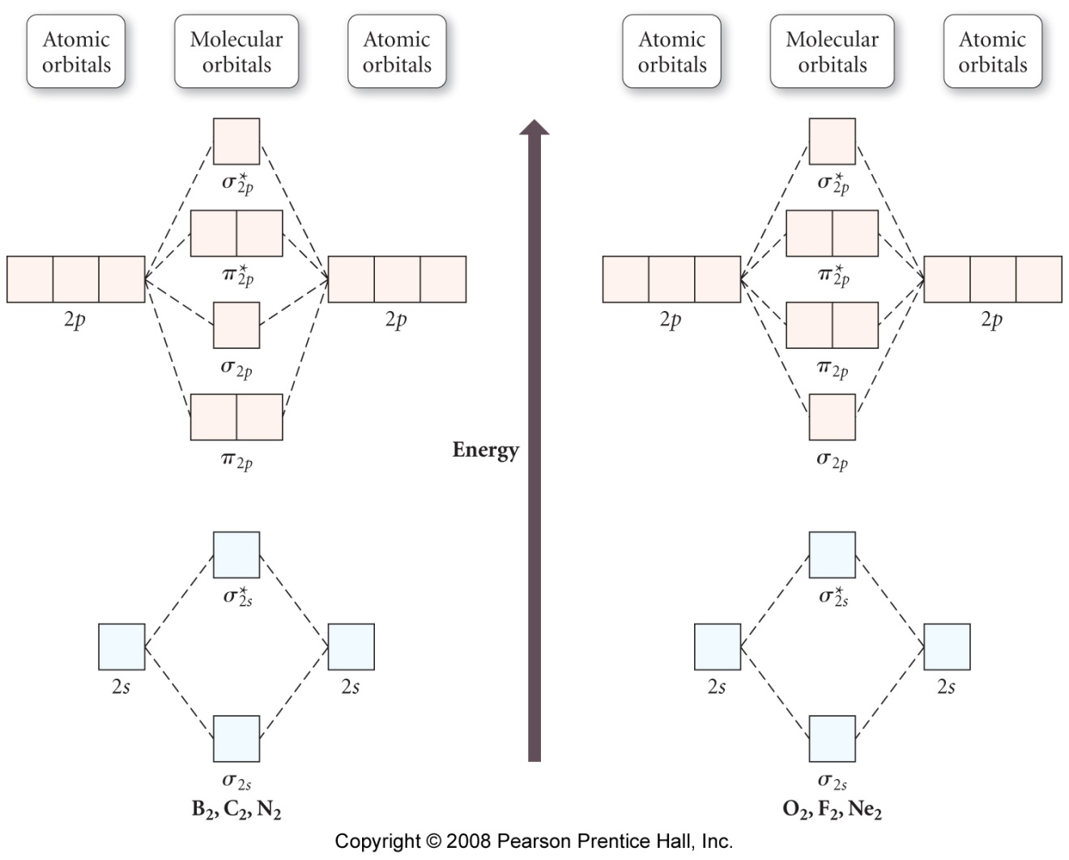

1. (5 points) Compare and contrast valence bond theory and molecular orbital theory.
2. (8 points) Look at the compound pictured below. Explain the bonding in terms of valence bond theory. That is show the atomic orbitals on the N atom, describe any electron promotion and hybridization necessary, and show the orbitals involved in both sigma and pi bonding as well as the orbital holding the lone pair of electrons.

